A Detailed Overview of IPv6
A Detailed Overview of IPv6: Addressing the Future of Networking
1. The Need for IPv6 and Addressing IPv4 Exhaustion
The internet has experienced massive growth since its inception, with millions of devices connecting daily. IPv4, the original internet protocol developed in the 1980s, was designed with a 32-bit address space, allowing for approximately 4.3 billion unique IP addresses. At the time of its creation, this seemed like more than enough to accommodate all devices. However, with the explosive growth of the internet, mobile devices, IoT (Internet of Things), and the global digital economy, IPv4 addresses have been exhausted.
The IPv4 exhaustion problem means that the available pool of IPv4 addresses has been depleted, which has led to workarounds like Network Address Translation (NAT) to conserve addresses. While NAT allows multiple devices to share a single public IPv4 address, it introduces complexities such as breaking end-to-end connectivity and making the network less scalable. This is where IPv6 comes in.
IPv6 (Internet Protocol version 6) was developed by the Internet Engineering Task Force (IETF) in the late 1990s as a long-term solution to the limitations of IPv4. With a much larger address space, IPv6 was designed to meet the growing demands of the internet while simplifying network operations.

2. Differences Between IPv4 and IPv6
The differences between IPv4 and IPv6 are both significant and transformative. While they serve the same fundamental purpose—allowing devices to communicate over networks—the design of IPv6 is a substantial improvement over its predecessor:
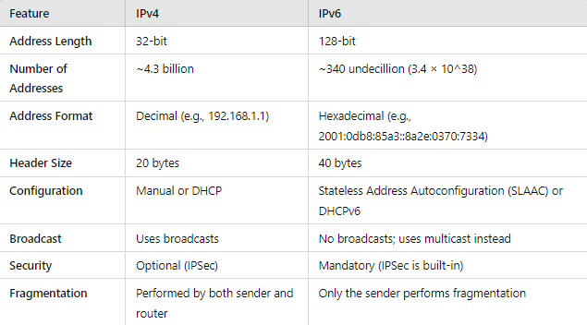

Some key differences are as follows:
- Address Space: IPv4’s 32-bit addresses offer 4.3 billion unique addresses. In contrast, IPv6 uses 128-bit addresses, yielding approximately 340 undecillion addresses (that’s 340 trillion trillion trillion). This astronomical number ensures that every device in the world can have a unique IP address, removing the need for workarounds like NAT.
- Improved Routing Efficiency: IPv6’s streamlined header structure is designed to improve routing efficiency. Routers no longer need to break apart headers as frequently as with IPv4, which reduces the processing load.
- Simplified Network Configuration: IPv6 supports Stateless Address Autoconfiguration (SLAAC), which allows devices to automatically generate their own IP addresses. This eliminates the need for DHCP (though DHCPv6 is still available for more controlled environments).
- Security: Unlike IPv4, where IPSec (Internet Protocol Security) is optional, IPv6 has IPSec built directly into its protocol stack. This ensures that IPv6 traffic can be more secure by default.

3. IPv6 Address Types
IPv6 introduces different types of IP addresses, each designed for specific network scenarios. These include Unicast, Multicast, and Anycast addresses.

4. Unicast Addresses in IPv6
Unicast addresses in IPv6 work similarly to those in IPv4: they identify a single network interface. Data sent to a unicast address is delivered to the specific device or interface corresponding to that address. However, IPv6 expands on this concept with several types of unicast addresses:
- Global Unicast Addresses (GUA):
  - These are equivalent to public IPv4 addresses and are globally routable on the internet. They are assigned to devices that need to communicate outside their local network.
  - Format: The first three bits of a global unicast address are fixed at 001, which results in addresses typically starting with "2" or "3" (e.g., 2001:db8::/32 is reserved for documentation).
  - Usage: These addresses are used for devices that need internet access and should be unique globally.
- Link-Local Addresses:
  - Link-local addresses are unique to a specific physical link (e.g., a local network segment) and are automatically generated without needing a router. These addresses are not routable beyond the local network.
  - Format: Link-local addresses always begin with the prefix fe80::/10. These addresses are essential for functions like neighbor discovery (via the Neighbor Discovery Protocol) and communication between devices on the same local network.
  - Usage: Used for communication within the local link, such as routers discovering each other or devices interacting in the absence of a DHCP server.
- Unique Local Addresses (ULA):
  - Unique Local Addresses in IPv6 are somewhat similar to private IPv4 addresses (e.g., 10.0.0.0/8, 192.168.0.0/16). ULAs are meant for internal use within an organization and are not routable on the global internet.
  - Format: ULAs start with the prefix fc00::/7. They are designed to be unique within an organization, allowing internal communications while preventing any overlap with public IPv6 addresses.
  - Usage: Useful in private networks or company-wide infrastructures that do not need internet exposure.

5. Multicast in IPv6
Multicast addresses are used to deliver packets to multiple devices (or nodes) simultaneously. Unlike broadcast (used in IPv4), which sends packets to all devices on a network, multicast allows for more efficient communication by only sending packets to a specific group of devices that have joined a multicast group.
- IPv6 Multicast Address Format: Multicast addresses begin with ff00::/8, and the next bits define the scope of the multicast (e.g., local network or global).
- Usage: Multicast is useful for tasks such as video streaming, network discovery, and resource location in IPv6. For instance, when a device needs to find other devices or services on a network, it can send a request to a multicast address rather than flooding the entire network.
- Common IPv6 Multicast Addresses:
  - All-Nodes Multicast: ff02::1 is used to send packets to all devices on a local link.
  - All-Routers Multicast: ff02::2 is used to send packets to all routers on a local link.

6. Anycast in IPv6
Anycast addresses are a unique feature of IPv6 that allows a packet to be delivered to one of several potential destinations. When a device sends data to an anycast address, the network automatically routes the packet to the nearest (in terms of network topology) node that holds that address.
- Anycast Address Format: Anycast addresses are not defined by a specific prefix but are assigned from the global unicast address pool. They are distributed to multiple devices, and routers decide which device is the closest for delivery.
- Usage: Anycast is commonly used for load balancing and redundancy. For example, a global web service might use anycast to route requests to the nearest server, improving performance for users and reducing latency.

7. Conclusion
IPv6 brings significant improvements to the world of networking, from its vastly expanded address space to its improved routing efficiency and network configuration capabilities. It eliminates many of the limitations that plagued IPv4, particularly with regards to address exhaustion, and offers a more scalable and secure solution for the future. Understanding IPv6 addressing, and the differences between unicast, multicast, and anycast, is crucial for network professionals as the world transitions toward a more IPv6-dominated internet.

